Name: Elvia Gisella Adair
Assignment: GitHub Repository Setup

For this module’s assignment, we will be creating a GitHub repository using Git and the command line interface (CLI). The repository we create in this assignment will be used throughout the course to host the coding assignments. If you have not already installed Git, please do so before continuing. Different versions of git can be found at: https://git-scm.com/

- Link to your GitHub repository.
https://github.com/gisellaadair/CSD-340

- Screenshot of your local directory (properly formatted).
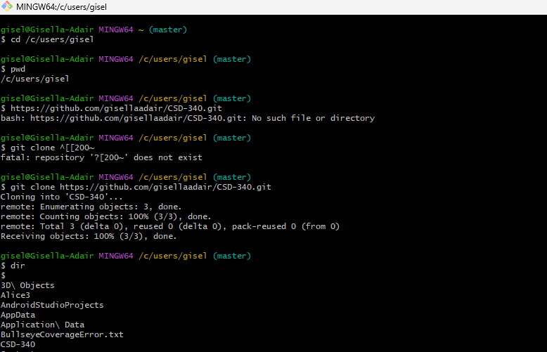

- Screenshot of your GitHub repository.
